**Project Planning Phase**

**Project Planning Template (Product Backlog, Sprint Planning, Stories, Story points)**

|  |  |
| --- | --- |
| Date | 26 June 2025 |
| Team ID | LTVIP2025TMID59601 |
| Project Name | orderonthego: your on-demand food ordering solution |
| Maximum Marks | 5 Marks |

**Product Backlog, Sprint Schedule, and Estimation (4 Marks)**

Use the below template to create product backlog and sprint schedule

|  |  |  |  |  |  |  |
| --- | --- | --- | --- | --- | --- | --- |
| **Sprint** | **Functional**  **Requirement (Epic)** | **User Story**  **Number** | **User Story / Task** | **Story Points** | **Priority** | **Team**  **Members** |
| Sprint-1 | User Authentication | USN-1 | As a user, I can register for the application by entering my email and password. | 2 | High | Dev Team |
|  |  | USN-2 | As a user, I can log into the application by entering my email and password. | 1 | High | Dev Team |
|  | Profile Management | USN-3 | As a user, I can view and update my profile information (name, email). | 3 | High | Dev Team |
|  | Search & Order | USN-4 | As a user, I can view a list of restaurants and their menus. | 3 | High | Dev Team |
|  |  | USN-5 | As a user, I can add food items to my cart and place an order. | 5 | High | Dev Team |
|  |  | USN-6 | As a user, I can see the status of my order in real-time (e.g., pending, delivered). | 3 | High | Dev Team |
|  | Restaurant Management | USN-7 | As a restaurant owner, I can register and await admin approval. | 3 | High | Dev Team |
|  | Admin Functions | USN-8 | As an admin, I can approve or reject new restaurant owner accounts. | 3 | High | Dev Team |
| Sprint-2 | Restaurant Management | USN-9 | As a user, I will receive confirmation email once I have registered for the application | 3 | High | Dev Team |
|  | Menu Management | USN-10 | As a user, I can register for the application through Facebook | 5 | High | Dev Team |
|  | Order Processing | USN-11 | As a restaurant owner, I can view new orders and update their status. | 3 | High | Dev Team |
|  | Feedback | USN-12 | As a user, I can submit feedback for a restaurant. | 3 | Medium | Dev Team |
|  |  | USN-13 | As an admin, I can manage (add, edit, delete) food categories for the system. | 4 | High | Dev Team |
|  | Reporting | USN-14 | As an admin, I can generate reports on order trends and top restaurants. | 5 | High | Dev Team |
|  | Admin Functions | USN-15 | As an admin, I can manage promoted restaurants. | 3 | Medium | Dev Team |
|  | Refinements | USN-16 | Performance optimizations and bug fixing across the application. | 5 | High | Dev Team |

**Project Tracker, Velocity & Burndown Chart: (4 Marks)**

|  |  |  |  |  |  |  |
| --- | --- | --- | --- | --- | --- | --- |
| **Sprint** | **Total Story Points** | **Duration** | **Sprint Start Date** | **Sprint End Date (Planned)** | **Story Points**  **Completed (as on**  **Planned End Date)** | **Sprint Release Date (Actual)** |
| Sprint-1 | 24 | 4 Days | 17 June 2025 | 20 June 2025 | 24 | 20 June 2025 |
| Sprint-2 | 30 | 5 Days | 21 June 2025 | 25 June 2025 | 30 | 25 June 2025 |

**Velocity:**

Imagine we have a 10-day sprint duration, and the velocity of the team is 20 (points per sprint). Let’s calculate the team’s average velocity (AV) per iteration unit (story points per day)

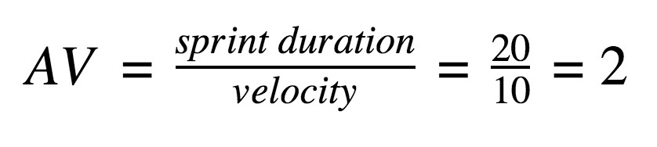

**Burndown Chart:**

A burn down chart is a graphical representation of work left to do versus time. It is often used in agile [software development](https://www.visual-paradigm.com/scrum/what-is-agile-software-development/) methodologies such as [Scrum.](https://www.visual-paradigm.com/scrum/scrum-in-3-minutes/) However, burn down charts can be applied to any project containing measurable progress over time.

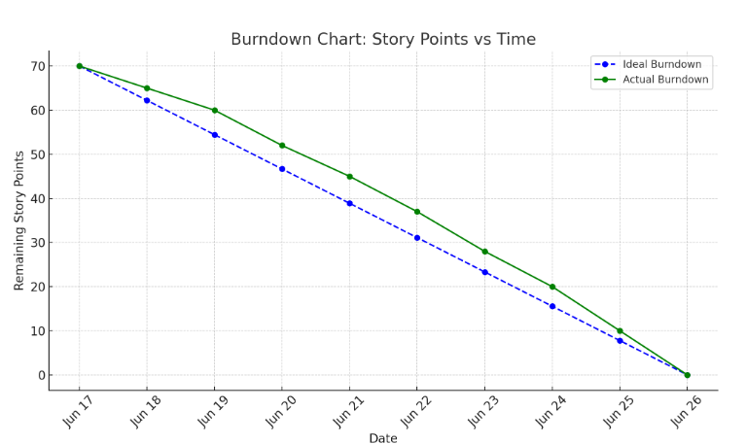

**Reference:**

<https://www.visual-paradigm.com/scrum/scrum-burndown-chart/>

<https://www.atlassian.com/agile/tutorials/burndown-charts>

<https://www.atlassian.com/agile/tutorials/how-to-do-scrum-with-jira-software>